
Military Health System
Facilities Share Service

MANUAL

NUMBER 8190.01, Volume 2
XX xxx 2015

Facilities Shared Service

SUBJECT: Defense Medical Logistics Standard Support – Facilities Management (DMLSS-FM):
Requirements Module

References: See Enclosure 1

1. PURPOSE. In accordance with the authority in references (a) and (b), this manual implements policy, assigns responsibilities, and provides procedures for managing data in the Military Health System’s (MHS) Computer Aided Facility Management/Computerized Maintenance Management System (CAFM/CMMS) of record, DMLSS-FM.

2. APPLICABILITY. This manual is applicable to all of the Defense Health Agency (DHA) and the Military Services. It applies to all facilities supported with Defense Health Program (DHP) funds.

3. RESPONSIBILITIES. See Enclosure 2.

4. PROCEDURES. The procedures in this manual address standardized use of DMLSS-FM for CMMS and CAFM functions for the MHS facilities portfolio. See Enclosure 3.

- RELEASABILITY. Unlimited. This manual is approved for public release and is available on the Internet from the World Class Toolkit, https://facilities.health.mil/home/OPS/FM.

6. EFFECTIVE DATE. This manual:

a. Is effective immediately upon signature by the Health Facilities Executive Council (HFEC).

  - Must be reissued, cancelled, or certified current within 5 years of its publication to be considered current in accordance with DHA Facilities Shared Services Issuance guidance, reference (c).

  - Will expire effective 10 years from publication date and be removed from the World Class Toolkit, if it hasn’t been reissued or cancelled in accordance with reference (c).

John A. Becker COL Michael D. Brennan, PhD
Director, DHA Facilities Division Commander, HFPA
G9-Facilities, MEDCOM

Paul S. McComb, P.E. Lt Col Ann Marie McCain
Director of Facilities, M41 Chief, Health Facilities Division
Bureau of Medicine and Surgery, U.S. Navy USAF

Enclosures
1. References
2. Responsibilities
3. Procedures
Glossary

TABLE OF CONTENTS

ENCLOSURE 1: REFERENCES 3
ENCLOSURE 2: RESPONSIBILITIES 4
1. DIRECTOR, DHA. 4
2. DIRECTOR, DHA FACILITIES 4
3. DOD MEDICAL COMPONENTS 4
ENCLOSURE 3: REQUIREMENTS MODULE PROCEDURES 5
1. FACILITY REQUIREMENTS. 5
a. Requirements. 5
b. Creating a Facility Requirement 5
c. Requirements Packages 13
d. Attachments 19
e. Cancel Rqmt 19
f. Create WR 19
g. Create Proj 19
2. DESIGN/DESIGN-BUILD RFP DEVELOPMENT REQUIREMENTS. 19
a. Creating a Design/Design-Build RFP Development Requirement 19
b. Attachments 24
c. Cancel Rqmt 24
d. Create Proj 24
3. IO&T REQUIREMENTS. 24
a. Creating an IO&T Requirement 24
b. Attachments 28
c. Cancel Rqmt 28
d. Create Proj 29
ENCLOSURE 4: Quick Reference Chart of DMLSS Data Used in Form DD1391 30
ENCLOSURE 5: Visual Reference Guide to Form DD1391 32
GLOSSARY 38

Table 1: Requirement Type Definitions 7
Table 2: Requirement Code Table 8
Table 3: Priority Level Table 8
Table 4: Requirement Criticality Table 9
Table 5: Requirement Source Table 10
Table 6: Requirement Estimate Source Type Table 11
Table 7: Overhead Type Table 18

ENCLOSURE 1

REFERENCES

- DoD Directive 5136.13, “Defense Health Agency (DHA),” September 30, 2013
- DoD Instruction 6015.17, “Military Health System (MHS) Portfolio Management,” January 13, 2012
- DHA Facilities Shared Services Issuance Guidance
- DoD 7000.14-R, “Department of Defense Financial Management Regulations (FMRs),” current edition
- Unified Facilities Criteria 3-701-01, “DoD Facilities Pricing Guide,” March 2011, as amended

ENCLOSURE 2

RESPONSIBILITIES

- DIRECTOR, DHA. The DHA Director shall:

    - Implement policy, guidance, and instructions consistent with references.

- Prepare and submit program and budget requirements for MHS facilities sustainment,
restoration, and modernization pursuant to guidance of the ASD(HA) for the DoD Planning, Programming, Budgeting, and Execution (PPBE) process in accordance with reference (a).

- Provide programmatic oversight of the DHP O&M appropriations in accordance with
instructions issued by the ASD(HA), fiscal guidance issued by the Under Secretary of Defense (Comptroller)/Chief Financial Officer, DoD (USD(C)/CFO), and applicable law.
- DIRECTOR, DHA FACILITIES.

The Director, DHA Facilities shall:

- Establish DMLSS-FM data standards for effective CAFM/CMMS management and
operations.
- Monitor medical facilities operations to ensure conformance with established
standards.
- Program and budget for CAFM/CMMS maintenance requirements to be submitted by the
Director, DHA for the DoD PPBE process.
- Develop and implement training for Services Facilities Staff on DHA directed data management
standards and reporting.

- DOD MEDICAL COMPONENTS.

- Monitor and report the overall condition, readiness, utilization, and functionality of
the Military Health System (MHS) facility portfolio.
- Establish internal controls to ensure compliance with established medical facility data
management standards.
ENCLOSURE 3

REQUIREMENTS MODULE PROCEDURES

FACILITY REQUIREMENTS.

The Requirements Module in DMLSS-FM is designed to provide a convenient place to capture data about future needs of the facility, i.e., unfunded requirements. Unfunded requirements may be identified through a variety of sources including: formal condition assessments, engineering studies, A/E analysis, informal inspections, commander walk-through, maintenance technician observations, etc. The data from the Requirements Module is used to calculate the Facility Condition Index (FCI), which directly impacts Restoration and Modernization funding.

Requirements.
A Requirement is defined as unfunded liability/deficiency. Requirements fall into three categories; Sustainment, Restoration, or Modernization.
    - Sustainment. Sustainment requirements are defined as major repairs or replacement of facility components that are expected to occur periodically throughout the life cycle of facilities. This work includes regular roof replacement, refinishing of wall surfaces, repair and replacement of heating and cooling systems, replacing tile and carpeting and similar types of work, per reference (d).
    - Restoration. Restoration means the restoration of real property to such a condition that it may be used for its designated purpose. Restoration requirements include repair and replacement work to restore facilities damaged by inadequate sustainment, excessive age, natural disaster, fire, accident or other causes, per reference (d).
    - Modernization. Modernization includes alteration of facilities solely to implement new or higher standards (including regulatory changes), to accommodate new functions, or to replace building components that typically last more than 50 years (such as foundations and structural members), per reference (d).

  - Creating a Facility Requirement.

Individual Requirements can serve two purposes. First, they may stand on their own, identifying a deficiency or requirement of any given facility. Secondly, they serve as the building blocks of a Requirements Package, from which a DD1391 can be generated. This section will go over the basic process of creating an Individual Requirement, as well as information specific to ensuring a proper DD1391 can be generated in the future, should Individual Requirements be combined to form a Requirements Package. Note: A DD1391 cannot be generated for a single Individual Requirement; it must be packaged into a Requirements Package by itself first.
    - In the Facility Management Application, navigate to the Requirements Module.

    - Once the Requirements module is open, you may either create a new requirement or search for an existing requirement. Click the “New” button to begin the process of creating a new requirement.

    - Overview Tab. There are several important data fields on the Overview tab. Presented here is a list of each of these fields with information on how to appropriately fill these out and how they impact the DD1391. For dropdown fields, a list of valid values will be shown. Fields in Bold are required by DHA standards, even if they are not required by DMLSS.

      - Installation. Select the installation.

      - Facility. Select the facility. An individual Requirement can be associated with only one facility. All Individual Requirements that are packaged into a Requirements Package must have the same Facility in order to generate a DD1391. Note: Once you save the Requirement, you will no longer be able to change the Facility or Installation.

      - Interim Fac#. Interim Facility Number is only to be populated if the Requirement is for a new facility that does not currently exist.

      - Facility Type. Defaults in from the Facility Inventory module once a Facility is selected.

      - Primary UM. Primary Unit of Measure defaults in from the Facility Inventory module once a Facility is selected.

      - Requester. Defaults to the Facility Manager as captured in the MTF Information module.

      - Telephone. Defaults to the Facility Manager’s phone number as captured in the Directory module.

      - Subject/Title. Requirement titles and descriptions should concisely state what needs to be done. The Requirement title should be in action verb-noun format, e.g. convert restrooms to shower areas. The title is a brief synopsis of the overall work being requested. This is the title that will appear in the list of Individual Requirements in Block 9 of the DD1391. The title is limited to 40 characters.

      - Requirement Type. Select the value that best corresponds to the Requirement, keeping in mind that RECAPITALIZATION includes both RESTORATION and MODERNIZATION. Requirement Type will determine where the cost for this requirement is grouped in the SRM Class Breakdown in the Additional Data section of the DD1391. There are seven valid options:

Requirement Type | Definition  Reference (d)
Demolition | Resulting in the decrease of a building's footprint as reported in the Real Property Inventory (RPI) or complete removal of a building from the RPI.
New Foot Print | Construction meant to build, develop, convert or extend real property and real property systems or components.
Sustainment | The maintenance and repair activities necessary to keep an inventory of facilities in good working order. It includes regularly scheduled adjustments and inspections, preventive maintenance tasks, and emergency response and service calls for minor repairs. It also includes major repairs or replacement of facility components (usually accomplished by contract) that are expected to occur periodically throughout the life cycle of facilities. This work includes regular roof replacement, refinishing of wall surfaces, repairing and replacement of heating and cooling systems, replacing tile and carpeting and similar types of work. It does not include environmental compliance costs, facility leases or other tasks associated with facilities operations (such as custodial services, grounds services, waste disposal and the provision of central utilities).
Recapitalization | The major renovation or reconstruction activities (including facility replacements) needed to keep existing facilities modern and relevant in an environment of changing standards and missions. Recapitalization extends the service life of facilities or restores lost service life. It includes restoration and modernization of existing facilities. Recapitalization encompasses both renovation and replacement of existing facilities.
Mothball/Caretaker | Minimum maintenance requirements for safety and security.
Dispose | Transfer to non-DoD entity.
Transfer | Transfer to DoD entity.
Table 1: Requirement Type Definitions
      - Requirement Class. Specifies whether the requirement relates to a condition or capability of the facility. This field is not shown on the DD1391, however it does relate to the Facility Condition Index (FCI). The two choices here are CONDITION or CAPABILITY. The system defaults to CONDITION. A Requirement should be classified as CAPABILITY only if it is related to an expanded or modified mission. For example, the need to build an addition on a clinic due to an increased active duty population would be a CAPABILITY Requirement. The need to build an exterior stairwell to correct a dead end corridor life safety deficiency would be a CONDITION Requirement. NOTE: These values are DMLSS-FM Managed and cannot be edited by the user.

      - Requirement Code. Select the value that best corresponds to the Requirement, using the definitions in the table below. NOTE: These values are DMLSS-FM Managed and cannot be edited by the user.

Capability | The ability of a facility to operate and perform its defined mission, function and/or operational business plan.
Code Compliance | Identifies a facility, system, or component deficiency that is not fully in compliance with an issued law, regulation, safety code, or generally safe practices.
Environmental | Identifies an environmental deficiency within a facility, system, component, or by-product that directly relates to adverse environmental practices or regulations.
Integrity | Identifies unreliable or degraded facilities, systems, or components.
Mission | Identifies requirements related to the operations and sustainment of the assigned mission.
Operational | Identifies sustainment or replacement needs within a facility system to maintain a safe and reliable environmental.
Quality of Life | Identifies deficiencies that reflect less than optimal operational environment, condition, or capability.
Safety | Identifies safety deficiencies within a facility or system.
Table 2: Requirement Code Table
      - Program Type. Determines how the requirement will be funded. This field is not required for Individual Requirements.

      - Priority Level. Select the value that best corresponds to the requirement priority. There are four valid options:

Must Fund | Legislatively mandated; required by statute; fact-of-life bill.
High | Issue supports an MHS Strategic Initiative/Imperative or line of effort and demonstrates a high return on investment (clinically or financially) to the MHS.
Medium | Issue supports an MHS Strategic Initiative/Imperative or line of effort and may demonstrate a moderate return on investment (clinically or financially) to the MHS.
Low | Issue does not support an MHS Strategic Initiative/Imperative or line of effort and does not appear to have significant impact to the MHS
Table 3: Priority Level Table
      - Criticality. A code determined by the probability of the occurrence of a mishap or facility failure and the severity of the deficiency. NOTE: These values are DMLSS-FM Managed and cannot be edited by the user.

1 – Imminent | Likely to occur immediately, may cause death and/or major property damage.
2 - Serious | Moderate property damage probably will occur in time, may cause severe injury and/or property damage.
3 – Moderate | Moderate property damage probably will occur in time, may cause minimal injury and/or property damage.
4 – Minor | May occur in time, may cause minor injury and/or minor property damage.
5 - Negligible | Unlikely to occur; will not cause injury, illness, or property damage.
Table 4: Requirement Criticality Table
      - Include in FCI indicator. The FCI is computed for each facility and is the sum of the estimates for all open Requirements (with Classification = CONDITION) for that facility divided by the Plant Replacement Value (PRV) for that facility. The intent of this field is to allow the user to specifically exclude some Requirements from the FCI calculation.

      - Facility System. This field is the system affected by the requirement, if applicable.

      - Facility Subsystem. This field is the subsystem affected by the requirement, if applicable.

      - Design FY. This field is the fiscal year planned for the design, if required. Follows the YYYY format.

      - Work FY. Enter the desired year of funding needed for work/construction start. Use current fiscal year only for projects that can be obligated by year end.

      - Local Project #. This field is not required for an Individual Requirement.

      - Hazard Severity. A scale of one to four determining the criticality of the requirement based on any hazardous conditions.

      - Probability. The mishap or failure probability of the deficiency, used in determining the criticality.

      - Work Method. The classification of work of the requirement. This will determine where the cost for this requirement is grouped in the Work Classification Breakdown in Block 9 of the DD1391.

      - Category. This field is a more specific category of the requirement as it relates to the Requirement Code. Local use. No standard for this field.

      - Associated Requirements Package. If this is an individual Requirement that is associated to a Requirements Package, the Requirements Package number will display here. Requirements Package numbers have an RP prefix.

      - Associated WR. If the Requirement has been converted to a work request, this field will display the work request number.

      - Associated Project. If the Requirement has been converted to a project, this field will display the project number.

      - Description. Enter a description of the Requirement. There is no need to specify the “Action” Title of the requirement here. Note: This field now allows for mixed-case entries. Clicking the “…” button will call a separate modal window where the Description can be entered.

    - Detail -1 Tab.

      - Source. This field is used to identify how a Requirement was generated. The definitions are shown in the table below. Select the value that most closely matches. NOTE: These values are DMLSS-FM Managed and cannot be edited by the user.

Business Initiative | Identifies a condition or capability deficiency related to accomplishing the mission or business plan.
Life Cycle | Identifies a facility, system, or component where a deficiency is identified as the result of life-cycle management.
Local | Identification of a condition or capability deficiency by the local authority having jurisdiction.
Technical Assessment | Identifies deficiencies of a facility, system, or component based on a condition assessment.
Table 5: Requirement Source Table
      - Room Number/Other Location. Populate as appropriate. Room numbers should be selected over other location in order to accurately record the history of work against that room. Before a Requirement can be turned into a work request, at minimum, a room number and/or other location will be required.

      - RPIE. This field identifies any RPIE associated with or affected by the requirement.

      - Area Supported. Populate as appropriate the area supported by the Requirement.

      - Local Use Fields. Local use. No standard for these fields.

      - Engineering Number. The number assigned to the requirement by the installation civil engineering or Public Works, if applicable.

      - Requirement Area. The area affected by the requirement.

      - Adequate Area. Not required for an Individual Requirement.

      - Substandard Area. Not required for an Individual Requirement.

      - Justification. Should include the benefits expected or impact if not accomplished. Include the code, standard, or statute that supports the project. For example, if the project is needed to correct a Safety Code deficiency, be sure to include the specific paragraph reference in the justification.

    - Detail-2 Tab. The Detail-2 Tab contains 8 data fields that are generally only used for a Requirements Package and will be covered in that section. These fields may be filled out on an Individual Requirement, but they will not show up on the DD1391.

    - Estimate Tab. The Estimate Tab contains basic financial data about the Individual Requirement.

      - Estimate Source Type. This field is used to identify the level at which the estimate originated. From the dropdown list, select the best choice.

A/E | Identifies the estimate was provided by an architect/engineer firm.
Installation Engineer | Identifies the estimate was provided by the Installation Engineer, e.g. PW, CE, or DPW
Local | Identifies the estimate was provided by local appraisal.
Table 6: Requirement Estimate Source Type Table
      - Estimate Source. This field is used to record the name of the organization responsible for developing the cost estimate. The choices in this field come from the FM Directory module. Select the appropriate value from the list. If the desired organization is not in the list, click on the blue running man to the left which jumps to the Directory Module, where the person can be added to the organization.

      - Estimator Name. This field is used to record the name of the person responsible for developing the cost estimate. The choices in this field come from the FM Directory module. Choices are limited to the POCs associated with the Estimate Source organization. Select the appropriate value from the list. If the POC is not available in the drop down list, go to the FM Directory module to add the individual under the appropriate organization.

      - Funding Source. The proposed expense center that will fund the Requirement when executed. Note: This is not actually linked to any of the financial data in DMLSS. It is for display only and does not affect or relate to any other module of DMLSS.

      - Estimate Date. Enter the date the estimate was developed.

      - Design ($). Design estimate.

      - Work ($). The estimate amount for the Individual Requirement. This amount will come from the Cost Estimating Worksheet, once it is saved.

      - Execution Method. Enter the execution method for the requirement: Design, DB development, Construction, IO&T.

      - Temporary Facility Costs ($). Costs associated with procuring, installing and occupying temporary structures. These costs are usually funded outside of the project.

      - Equipment from Other Appropriations ($). Costs, associated with equipment, which are funded by other appropriations.

      - Cost Estimating Worksheet. The Cost Estimating Worksheet contains a detailed cost estimate for the Requirement. It is accessed by clicking the “Worksheet” button on the right hand side of the screen.

        - Line Items. Line items can be added or removed by using the “Add” and “Delete” buttons, respectively. Each Line Item has five basic columns:

          - Item Description. A brief description of the line item (holds up to 255 characters).

          - U/M: Unit of Measure. This should be a conventional unit of measure (holds up to 10 characters).

          - Quantity. Allows up to 2 decimal places.

          - Unit Cost. Allows up to 2 decimal places.

          - Extended Cost. Automatically calculated by the system.

        - Once saved, the system will now overwrite the Work ($) field on the estimate tab with the Total Funded Cost. If there is already an amount in the Work ($), you will be prompted if you wish to overwrite the old amount with the new amount. The worksheet will be saved regardless of your choice. IMPORTANT NOTE: This functionality allows the Work ($) to differ from the total on the worksheet. The amount shown in the Work ($) field is the amount that will show in Block 9 of the DD1391, regardless of what is on the worksheet.

        - Adjustment Factor and Overhead Costs. Adjustment factor and overhead costs may be entered for an Individual Requirements; however, they will not carry over when the requirement is packaged into a Requirements package. It is advised that these fields be populated on Requirements Packages only.

    - Status Tab.

      - Comments. The Comments field that displays next to the Requirement Status is intended to provide a place to capture a brief (50 character) update that would then be included on a Business Objects status report. For example, a Requirement may be open for many years, but during that time it may be given to different organizations for review or to develop estimates, etc. During this time, the status remains “OPEN,” but more detail is often needed for reporting purposes. Additional detailed information needs to be captured in the Status Actions button. As updates occur, clear out the old data in the Comments field and replace it with new data. To ensure a historical record, each time an update is made to the Comments field, put the same information (but in more detail) into the Actions field. Do not use the Notes icon. Note: If information is only captured in the comments field and not the actions field – the information will be overwritten by the next comment. The comments field should be used to capture the current status of a Requirement since the current status cannot be updated manually.
      - Design Status. The Design Status and Explanation can be noted on Individual Requirements; however, this information does not appear on the DD1391. The Design Status Explanation field can hold up to 255 characters and allows for mixed-case entries.

  - Requirements Packages. The ability to package one or more Requirements is intended for funding and project execution purposes. If you wish to generate a DD1391 from one Individual Requirement, you must package the single requirement by itself. Requirements Packages used to generate a DD1391 must contain only Individual Requirements from the same facility. Once the Individual Requirements are packaged, the new Requirements Package Detail screen will load.

    - Overview Tab. The data in this tab now relates to the Requirements Package. The fields are identical to the Individual Requirements. Several fields will automatically generate information from the Individual Requirements. A majority of the data comes from the first Individual Requirement in the package.

      - Installation. Automatically generated from the first Individual Requirement in the package.

      - Facility. Automatically generated from the first Individual Requirement in the package.

      - Interim Fac#. Automatically generated from the first Individual Requirement in the package.

      - Facility Type. Automatically generated from the first Individual Requirement in the package.

      - Primary UM. Automatically generated from the first Individual Requirement in the package.

      - Requester. Defaults to the Facility Manager as captured in the MTF Information module.

      - Telephone. Defaults to the Facility Manager’s phone number as captured in the Directory module.

      - Subject/Title. This will be the Project Title (Block 4) on the DD1391. This field has a limit of 41 characters. Do not include the Facility Number or Name here, as those will be automatically filled in when the DD1391 is generated.

      - Requirement Type. Select the value that best corresponds to the majority of work included in the Requirements Package. Refer to table 1 for valid entries and definitions.

      - Requirement Class. Select the value that best corresponds to the majority of work included in the Requirements Package.

      - Requirement Code. Select the value that best corresponds to the majority of work included in the Requirements Package. Refer to table 2 for valid entries and definitions.

      - Program Type. Determines how the requirement will be funded. This field combines with the “Work FY” field to form the Title Block of the 1391. For example, a Work FY of 2014 combined with a Program Type of “MILCON” would generate a title of “2014 Military Construction Program.”

      - Priority Level. Select the value that best corresponds to the Requirements Package priority. Refer to table 3 for valid entries and definitions.

      - Criticality. A code determined by the probability of the occurrence of a mishap or facility failure and the severity of the deficiency. This field combines with “Requirement Code” to determine the Criticality Code in the DD1391. The first letter of the Requirement Code (M, S, Q, or E) will be combined with the “Criticality” field in the Additional Info section of the DD1391. For example, a Code of “Mission” would combine with a Criticality of “2 – SERIOUS” to become “M2 – SERIOUS.” Note: If “1 – IMMINENT” is selected, it will appear as “1 – CRITICAL” on the DD1391.

      - Include in FCI indicator. Should never be checked on a Requirements Package.

      - Facility System. Not required for a Requirements Package. Only fill-in when the Requirements Package addresses only one facility system.

      - Facility Subsystem. Not required for a Requirements Package. Only fill-in when the Requirements Package addresses only one facility system/subsystem.

      - Design FY. This field is the fiscal year planned for the design, if required. Follows the YYYY format.

      - Work FY. Enter the desired year of funding needed for work/construction start. Use current fiscal year only for projects that can be obligated by year end.

      - Local Project #. This field will populate the Project Number (Block 7) of the DD1391. Format specified by Services. This should be the same Local Project # used for the associated Design/Design-Build RFP Development and IO&T Requirements, if applicable. This must be a Globally Unique Identifier.

      - Hazard Severity. Not required for a Requirements Package.

      - Probability. Not required for a Requirements Package.

      - Work Method. Not required for a Requirements Package.

      - Category. Not required for a Requirements Package.

      - Associated Requirements Package. Automatically generated.

      - Associated WR. Automatically generated.

      - Associated Project. Automatically generated.

      - Description. The Description of Proposed Construction (Block 10) of the DD1391. Note: When first packaged, this field will show the Descriptions of all of the Individual Requirements.

    - Detail-1 Tab.

      - Source. Not Required for a Requirements Package.

      - Room Number/Other Location. Populate as appropriate. Room numbers should be selected over other location in order to accurately record the history of work against that room. Before a Requirement can be turned into a work request, at minimum, a room number and/or other location will be required.

      - RPIE. This field identifies any RPIE associated with or affected by the requirement.

      - Area Supported. Populate as appropriate the area supported by the Requirement.

      - Local Use Fields. Local use. No standard for these fields.

      - Engineering Number. The number assigned to the requirement by the installation civil engineering or Public Works, if applicable.

      - Requirement Area. The area affected by the requirement.

      - Adequate Area. Populates to DD1391.

      - Substandard Area. Populates to DD1391.

      - Justification. Should include the benefits expected or impact if not accomplished. Include the code, standard, or statute that supports the project. For example, if the project is needed to correct a Safety Code deficiency, be sure to include the specific paragraph reference in the justification.

    - Detail-2 Tab. The Detail-2 tab contains 8 data fields, all of which appear on the DD1391. These large, open-text entry fields, technically known as CLOBs, allow for mixed-case entries up to 32,000 characters long. You may use the “…” button to bring up a separate modal window that may make typing easier. You may also wish to type up these entries in a word processor with a spell check feature, to ensure there are no typos. Note: Some special characters are not permitted.

      - Impact If Not Provided. Describes the impact, citing the extent and manner of adverse impact on mission accomplishment if the project is not accomplished.

      - Current Situation. Describes the current situation and how the requirement is presently met. Provides the year when the facility was originally completed and type of construction. If the existing facility is deteriorated or outdated, provides specific information that reflects those conditions, including appropriate critical backlog or Facility Condition Assessment (FCA) data and facility condition ratings.

      - Requirement Explanation. Provides the facts as to why the facility is essential to meet current operations.

      - HAZMAT Information. Specifies the amount, location and cost for asbestos, lead paint and any other hazardous material removal and disposal.

      - Project Explanation. Provides a brief statement on what the project does.

      - Economic Analysis. A systematic method for quantifying the costs and benefits of alternative solutions for achieving an objective in order to find the most efficient (economical) solution.

      - Phasing Summary. Phasing of a repair project includes the cost of each phase and the fiscal year planned for funding.

      - Other Projects. Describes any accomplished or proposed military construction or Non-Appropriated Funds (NAF) construction, repair and equipment installation project for the facility within the past 24 months and those planned in the next 12 months.

    - Estimate Tab. The Estimate Tab contains basic financial data about the Requirements Package. It operates in the same manner as the Estimate Tab for the Individual Requirement.

      - Estimate Source Type. This field is used to identify the level at which the estimate originated. From the dropdown list, select the best choice. Refer to table 6 for valid entries and definitions.

      - Estimate Source. This field is used to record the name of the organization responsible for developing the cost estimate. The choices in this field come from the FM Directory module. Select the appropriate value from the list. If the desired organization is not listed, click on the blue running man to the left which jumps to the Directory Module, where the person can be added to the organization.

      - Estimator Name. This field is used to record the name of the person responsible for developing the cost estimate. The choices in this field come from the FM Directory module. Choices are limited to the POCs associated with the Estimate Source organization. Select the appropriate value from the list. If the POC is not listed, go to the FM Directory module to add the individual under the appropriate organization.

      - Funding Source. The proposed expense center that will fund the Requirements Package when executed. Note: This is not actually linked to any of the financial data in DMLSS. It is for display only and does not affect or relate to any other module of DMLSS.

      - Estimate Date. Enter the date the estimate was developed.

      - Design ($). Design estimate. NOTE: For the design costs to be populated on the DD1391, they must be entered into the cost estimating worksheet.

      - Work ($). The Work Total ($) shows the cumulative total of the Work ($) amounts of the Individual Requirements. The Work ($) field is total cost for the Requirements Package. It can either be populated from the Worksheet or manually entered.

      - Execution Method. Enter the execution method for the requirement: Design, DB development, Construction, IO&T.

      - Temporary Facility Costs ($). Costs associated with procuring, installing and occupying temporary structures. These costs are not part of the total project costs on the DD1391, but are listed separately at the end of Block 9.

      - Equipment from Other Appropriations ($). Costs, associated with equipment, which are funded by other appropriations. These costs are not part of the total project costs on the DD1391, but are listed separately at the end of Block 9.

      - Facility System Assessment. The intent of this section was to provide a place to record high-level condition assessment data at the system and/or subsystem level. However, to avoid confusion, DHA policy is to leave this section blank. At this time, all condition assessment information should be captured on the individual RPIE items and recorded in BUILDER.

      - Cost Estimating Worksheet. The Cost Estimating Worksheet contains a detailed cost estimate for the Requirements Package. It is accessed by clicking the “Worksheet” button on the right hand side of the screen.

        - Line Items. When the Requirements Package was created, all line items from the Individual Requirements were automatically added to the Worksheet.

        - Adjustment Factor. This field defaults to 1.00, regardless of the Adjustment Factor of any of the Individual Requirements. The adjustment factor may be found in reference (e).

        - Adjusted Subtotal. Subtotal of the Requirements Package adjusted by the Adjustment Factor.

        - Overhead Costs. Line items may be added to capture the Overhead costs for a Requirements Package.

          - Overhead Type. There are 3 types of overhead captured here:

Contingency | The default is 10%.
SIOH | Supervision, Inspection, and Overhead of the execution agent. The default is 8%.
Planning and Design | There is no default percentage. This amount may be included or excluded from the Total Funded Cost, see the next section. Typically, on a Design-Bid-Build contract, the percentage is 10%. On a Design-Build contract, the percentage is typically 4%.
Table 7: Overhead Type Table
          - Description. A more detailed description of the Overhead value may be added here.

          - Percentage. The percentage of the subtotal used to estimate the overhead cost. Although a percentage may default in, this field may be modified.

          - Absolute Value. The absolute value will calculate based on the percentage. An absolute value may be entered as well, which will cause the percentage to be recalculated.

          - Total Overhead Costs. This is a subtotal of the overhead costs.

        - Include P/D Overhead in Total Funded Cost indicator. This checkbox allows the user to include or exclude the Planning and Design Amount from the Total Cost. The Planning and Design Amount will still be shown on the DD1391, but will be included or excluded from the amount shown in Block 8 based on this checkbox. This box should always be checked when the project is executed as Design-Build.

        - Total Funded Cost. The Total Funded Cost is the sum of the Requirements Package costs and the overhead costs. It is the amount that will appear in Block 8 of the DD1391.

        - Once saved, the system will overwrite the Work ($) field on the estimate tab with the Total Funded Cost. If there is already an amount in the Work ($), you will be prompted if you wish to overwrite the old amount with the new amount. The worksheet will be saved regardless of your choice. IMPORTANT NOTE: This functionality allows the Work ($) to differ from the total on the worksheet. The amount shown in the Work ($) field is the amount that will show in Block 9 of the DD1391, regardless of what is on the worksheet.

    - Status Tab.

      - Comments. The Comments field that displays next to the Requirements Package Status is intended to provide a place to capture a brief (50 character) update that would then be included on a Business Objects status report. For example, a Requirements Package may be open for several months or years, but during that time it may be given to different organizations for review or to develop estimates, etc. During this time, the status remains “OPEN,” but more detail is often needed for reporting purposes. Additional detailed information needs to be captured in the Status Actions button. As updates occur, clear out the old data in the Comments field and replace it with new data. To ensure a historical record, each time an update is made to the Comments field, put the same information (but in more detail) into the Actions field. Do not use the Notes icon. Note: If information is only captured in the comments field and not the actions field – the information will be overwritten by the next comment. The comments field should be used to capture the current status of a Requirements Package since the current status cannot be updated manually.

      - Design Status.

        - Status of Design. Enter the stage of the design. If the Requirements Package will be used to generate a DD1391 and there is no design, enter “Other” and provide an explanation in the next section.
        - Design Status Explanation. This field allows mixed-case entries up to 255 characters long. It is required when “Other” is selected. If the project is executed as Design-Build, specify it in this section.

  - Attachments. Attach files as necessary, i.e. A/E cost estimate.

  - Cancel Rqmt. The Cancel Requirement button is to be used when a Requirement is no longer valid, i.e. mission Requirements change, major renovations supersede previous requirement, etc. Caution: Once a Requirement is cancelled it cannot be reopened or edited. Ensure all comments and documentation are completed prior to cancelling. Once a Requirement is cancelled and there is no longer a need to view it in DMLSS-FM, set it inactive via System Services, Record Management.

  - Create WR. The Create Work Request button is to turn a funded Requirement into a Work Request for execution. The WR module is recommended for those Requirements that are less than $2,500 and can be completed within 60 days. If a Requirement is turned into a WR and not completed within 60 days, it will be reflected on the WR Greater Than 60 Days Old report. This can give the perception that the local maintenance team is not performing within required times.

  - Create Proj. The Create Project button is used to turn a funded Requirement into a Project. The Project module is recommended for those Requirements that will take longer than 60 days to complete and are over WR threshold as established in the maintenance contract. Projects completed in the Project module will be visible in the Key Events in Facility Inventory. A Requirement will remain open in the system until a construction contract is entered in the Project module to the associated Requirement. The Requirement will remain active in DMLSS until the Project or Requirement itself is manually set inactive.

DESIGN/DESIGN-BUILD RFP DEVELOPMENT REQUIREMENTS.

The Requirements Module is also used to communicate design and design-build RFP development requirements. These requirements also impact Restoration and Modernization funding. From the Requirements Module, activities may also indicate the readiness to accept funding for design/design-build RFP development requirements.

  - Creating a Design/Design-Build RFP Development Requirement.

Design and Design-Build RFP Development Requirements are created the same way as Individual Facility Requirements.
    - Overview Tab.

      - Installation. Select the installation.

      - Facility. Select the facility. An Individual Requirement can be associated to only one facility. Note: Once you save the Requirement, you will no longer be able to change the Facility or Installation.

      - Interim Fac#. Interim Facility Number is only to be populated if the Requirement is for a new facility that does not currently exist.

      - Facility Type. Defaults in from the Facility Inventory module once a Facility is selected.

      - Primary UM. Primary Unit of Measure defaults in from the Facility Inventory module once a Facility is selected.

      - Requester. Defaults to the Facility Manager as captured in the MTF Information module.

      - Telephone. Defaults to the Facility Manager’s phone number as captured in the Directory module.

      - Subject/Title. Requirement titles and descriptions should concisely state what needs to be done. The Requirement title should be in action verb-noun format, e.g. convert restrooms to shower areas. The title is a brief synopsis of the overall work being requested. Titles for Design should begin with “DESIGN:” and titles for Design-Build RFP Development should begin with D-B RFP:.” The title is limited to 40 characters.

      - Requirement Type. Select the value that best corresponds to the Facility Requirement associated with this Design or Design-Build RFP effort, keeping in mind that RECAPITALIZATION includes both RESTORATION and MODERNIZATION. There are four valid options. Refer to table 1 for valid entries and definitions.

      - Requirement Class. Specifies whether the Facility Requirement associated with the Design/Design-Build effort relates to a condition or capability of the facility.

      - Requirement Code. Select the value that best corresponds to the Facility Requirement associated with this Design/Design-Build RFP effort. Refer to table 2 for valid entries and definitions. NOTE: These values are DMLSS-FM Managed and cannot be edited by the user.

      - Program Type. Determines how the requirement will be funded. This field is not required for Individual Requirements.

      - Priority Level. Select the value that best corresponds to the Design/Design-Build RFP Development Requirement priority. Refer to table 3 for valid entries and definitions.

      - Criticality. Criticality is a code determined by the probability of the occurrence of a mishap or facility failure and the severity of the deficiency. Refer to table 4 for valid entries and definitions. This field should record the Criticality of the Facility Requirement associated with the Design/Design-Build RFP effort. NOTE: These values are DMLSS-FM Managed and cannot be edited by the user.

      - Include in FCI indicator. The FCI is computed for each facility and is the sum of the estimates for all open Requirements (with Classification = CONDITION) for that facility divided by the Plant Replacement Value (PRV) for that facility. The intent of this field is to allow the user to specifically exclude some Requirements from the FCI calculation. The Design/Design-Build RFP Development Requirements should be EXCLUDED from the FCI calculation, i.e. the box must be “UNCHECKED.”

      - Facility System. This field is the system affected by the Facility Requirement associated with the Design/Design-Build RFP effort, if applicable.

      - Facility Subsystem. This field is the subsystem affected by the Facility Requirement associated with the Design/Design-Build RFP effort, if applicable.

      - Design FY. This field is the fiscal year planned for the Design/Design-Build RFP effort, if required. Follows the YYYY format. Enter the desired year of funding needed for the Design/Design-Build RFP Development to start. Use current fiscal year only for Designs/Design-Build RFP Developments that can be obligated by year end.

      - Work FY. Enter the proposed year of construction for the related project.

      - Local Project #. Format specified by Services. This should be the same Local Project # used for the associated Facility and IO&T Requirements, if applicable. This must be a Globally Unique Identifier.

      - Hazard Severity. A scale of one to four determining the criticality of the Facility Requirement associated with the Design/Design-Build RFP effort based on any hazardous conditions.

      - Probability. The mishap or failure probability of the deficiency, used in determining the criticality.

      - Work Method. The classification of work of the Facility Requirement associated with the Design/Design-Build RFP effort. This may be determined during the Design/Design-Build RFP development.

      - Category. This field is a more specific category of the Facility Requirement associated with the Design/Design-Build RFP effort as it relates to the Requirement Code. Local use. No standard for this field.

      - Associated Requirements Package. If this is an individual Requirement that is associated to a Requirements Package, the Requirements Package number will display here. Requirements Package numbers have an RP prefix.

      - Associated WR. If the Requirement has been converted to a work request, this field will display the work request number.

      - Associated Project. If the Requirement has been converted to a project, this field will display the project number.

      - Description. Enter a description of the Design/Design-Build RFP Development effort here. Note: This field now allows for mixed-case entries. Clicking the “…” button will call a separate modal window where the Description can be entered.

    - Detail -1 Tab.

      - Source. This field is used to identify how the Facility Requirement associated with the Design/Design-Build RFP effort was generated. The definitions are shown in Table 4. Select the value that most closely matches. NOTE: These values are DMLSS-FM Managed and cannot be edited by the user.

      - Room Number/Other Location. Populate as appropriate. Room numbers should be selected over other location in order to accurately record the history of work against that room.

      - RPIE. This field identifies any RPIE associated with or affected by the requirement.

      - Area Supported. Populate as appropriate the area supported by the Requirement.

      - Local Use Fields. Local use. No standard for these fields.

      - Engineering Number. The number assigned to the requirement by the installation civil engineering or Public Works, if applicable.

      - Requirement Area. The area affected by the requirement.

      - Adequate Area. Not required for an Individual Requirement.

      - Substandard Area. Not required for an Individual Requirement.

      - Justification. Should include the benefits expected or impact if not accomplished. Include the code, standard, or statute that supports the project. For example, if the project is needed to correct a Safety Code deficiency, be sure to include the specific paragraph reference in the justification.

    - Detail-2 Tab. The Detail-2 Tab contains 8 data fields that are not generally used for Design/Design-Build Development Requirements.

    - Estimate Tab. The Estimate Tab contains basic financial data about the Individual Requirement.

      - Estimate Source Type. This field is used to identify the level at which the estimate originated. From the dropdown list, select the best choice. Refer to table 6 for valid entries and definitions.

      - Estimate Source. This field is used to record the name of the organization responsible for developing the cost estimate. The choices in this field come from the FM Directory module. Select the appropriate value from the list. If the desired organization is not in the list, click on the blue running man to the left which jumps to the Directory Module, where the person can be added to the organization.

      - Estimator Name. This field is used to record the name of the person responsible for developing the cost estimate. The choices in this field come from the FM Directory module. Choices are limited to the POCs associated with the Estimate Source organization. Select the appropriate value from the list. If the POC is not available in the drop down list, go to the FM Directory module to add the individual under the appropriate organization.

      - Funding Source. The proposed expense center that will fund the Requirement when executed. Note: This is not actually linked to any of the financial data in DMLSS. It is for display only and does not affect or relate to any other module of DMLSS.

      - Estimate Date. Enter the date the estimate was developed.

      - Design ($). Design estimate.

      - Work ($). The Work estimate should not be filled-in for a Design/Design-Build RFP Development Requirement.

      - Execution Method. Enter the execution method for this requirement: Design, DB development, Construction, IO&T.

      - Temporary Facility Costs ($). Should not be filled-in for a Design/Design-Build RFP Development Requirement.

      - Equipment from Other Appropriations ($). Should not be filled-in for a Design/Design-Build RFP Development Requirement.

      - Facility System Assessment. The intent of this section was to provide a place to record high-level condition assessment data at the system and/or subsystem level. However, to avoid confusion, DHA policy is to leave this section blank. At this time, all condition assessment information should be captured on the individual RPIE items and recorded in BUILDER.

    - Status Tab.

      - Comments. The Comments field that displays next to the Requirement Status is intended to provide a place to capture a brief (50 character) update that would then be included on a Business Objects status report. For example, a Requirement may be open for many years, but during that time it may be given to different organizations for review or to develop estimates, etc. During this time, the status remains “OPEN,” but more detail is often needed for reporting purposes. Additional detailed information needs to be captured in the Status Actions button. As updates occur, clear out the old data in the Comments field and replace it with new data. To ensure a historical record, each time an update is made to the Comments field, put the same information (but in more detail) into the Actions field. Do not use the Notes icon. Note: If information is only captured in the comments field and not the actions field – the information will be overwritten by the next comment. The comments field should be used to capture the current status of a Requirement since the current status cannot be updated manually.
      - Design Status. The Design Status and Explanation can be noted on Individual Requirements. The Design Status Explanation field can hold up to 255 characters and allows for mixed-case entries.

  - Attachments. Attach files as necessary, i.e. CE cost estimate.

  - Cancel Rqmt. The Cancel Requirement button is to be used when a Requirement is no longer valid, i.e. mission Requirements change, major renovations supersede previous requirement, etc. Caution: Once a Requirement is cancelled it cannot be reopened or edited. Ensure all comments and documentation are completed prior to cancelling. Once a Requirement is cancelled and there is no longer a need to view it in DMLSS-FM, set it inactive via System Services, Record Management.

  - Create Proj. The Create Project button is to turn a funded Requirement into a Project. Projects completed in the Project module will be visible in the Key Events in Facility Inventory. A Requirement will remain open in the system until a construction contract is entered in the Project module to the associated Requirement. The Requirement will remain active in DMLSS until the Project or Requirement itself is manually set inactive.

IO&T REQUIREMENTS.

The Requirements Module may also be used to communicate IO&T needs associated with an SRM project. These requirements may impact O&M and OP funding. From the Requirements Module, activities may also indicate the readiness to accept funding for IO&T requirements.

  - Creating an IO&T Requirement.

IO&T Requirements are created the same way as Individual Facility Requirements.
    - Overview Tab.

      - Installation. Select the installation.

      - Facility. Select the facility. An individual Requirement can be associated to only one facility. Note: Once you save the Requirement, you will no longer be able to change the Facility or Installation.

      - Interim Fac#. Interim Facility Number is only to be populated if the Requirement is for a new facility that does not currently exist.

      - Facility Type. Defaults in from the Facility Inventory module once a Facility is selected.

      - Primary UM. Primary Unit of Measure defaults in from the Facility Inventory module once a Facility is selected.

      - Requester. Defaults to the Facility Manager as captured in the MTF Information module.

      - Telephone. Defaults to the Facility Manager’s phone number as captured in the Directory module.

      - Subject/Title. Requirement titles and descriptions should concisely state what needs to be done. The Requirement title should be in action verb-noun format, e.g. convert restrooms to shower areas. The title is a brief synopsis of the overall work being requested. Titles for IO&T Requirements should begin with “IO&T:.” The title is limited to 40 characters.

      - Requirement Type. Select the value that best corresponds to the Facility Requirement associated with this IO&T Requirement, keeping in mind that RECAPITALIZATION includes both RESTORATION and MODERNIZATION.

      - Requirement Class. Specifies whether the Facility Requirement associated with the IO&T Requirement relates to a condition or capability of the facility.

      - Requirement Code. Select the value that best corresponds to the Facility Requirement associated with the IO&T Requirement. Refer to table 2 for valid entries and definitions. NOTE: These values are DMLSS-FM Managed and cannot be edited by the user.

      - Program Type. Determines how the requirement will be funded. This field is not required for Individual Requirements.

      - Priority Level. Select the value that best corresponds to the IO&T Requirement priority. Refer to table 3 for valid entries and definitions.

      - Criticality. Criticality is a code determined by the probability of the occurrence of a mishap or facility failure and the severity of the deficiency. Refer to table 4 for valid entries and definitions. This field should record the Criticality of the Facility Requirement associated with the IO&T Requirement. NOTE: These values are DMLSS-FM Managed and cannot be edited by the user.

      - Include in FCI indicator. FCI stands for Facility Condition Index. The FCI is computed for each facility and is the sum of the estimates for all open Requirements (with Classification = CONDITION) for that facility divided by the Plant Replacement Value (PRV) for that facility. The intent of this field is to allow the user to specifically exclude some Requirements from the FCI calculation. The IO&T Requirements should be EXCLUDED from the FCI calculation, i.e. the box must be “UNCHECKED.”.

      - Facility System. Should not be filled-in for IO&T Requirements.

      - Facility Subsystem. Should not be filled-in for IO&T Requirements

      - Design FY. Should not be filled-in for IO&T Requirements.

      - Work FY. Enter the proposed year of IO&T execution for the related project. Use current fiscal year only for IO&T requirements that can be obligated by year end.

      - Local Project #. Format specified by Services. This should be the same Local Project # used for the associated Facility and Design/Design-Build RFP Development Requirements, if applicable. This must be a Globally Unique Identifier.

      - Hazard Severity. A scale of one to four determining the criticality of the Facility Requirement associated with the IO&T Requirement based on any hazardous conditions.

      - Probability. The mishap or failure probability of the deficiency, used in determining the criticality.

      - Work Method. The classification of work of the Facility Requirement associated with the IO&T Requirement.

      - Category. This field is a more specific category of the Facility Requirement associated with the IO&T Requirement as it relates to the Requirement Code. Local use. No standard for this field.

      - Associated Requirements Package. If this is an Individual Requirement that is associated to a Requirements Package, the Requirements Package number will display here. Requirements Package numbers have an RP prefix.

      - Associated WR. If the Requirement has been converted to a work request, this field will display the work request number.

      - Associated Project. If the Requirement has been converted to a project, this field will display the project number.

      - Description. Enter a description of the IO&T Requirement here. Note: This field now allows for mixed-case entries. Clicking the “…” button will call a separate modal window where the Description can be entered.
    - Detail -1 Tab.

      - Source. This field is used to identify how the Facility Requirement associated with the IO&T Requirement was generated. Refer to table 5 for valid entries and definitions. Select the value that most closely matches. NOTE: These values are DMLSS-FM Managed and cannot be edited by the user.

      - Room Number/Other Location. Populate as appropriate. Room numbers should be selected over other location in order to accurately record the history of work against that room.

      - RPIE. This field identifies any RPIE associated with or affected by the requirement.

      - Area Supported. Populate as appropriate the area supported by the Requirement.

      - Local Use Fields. Local use. No standard for these fields.

      - Engineering Number. The number assigned to the requirement by the installation civil engineering or Public Works, if applicable.

      - Requirement Area. Not required for an IO&T Requirement.

      - Adequate Area. Not required for an IO&T Requirement.

      - Substandard Area. Not required for an IO&T Requirement.

      - Justification. Should include the benefits expected or impact if not accomplished. Include the code, standard, or statute that supports the project. For example, if the project is needed to correct a Safety Code deficiency, be sure to include the specific paragraph reference in the justification.

    - Detail-2 Tab. The Detail-2 Tab contains 8 data fields that are not generally used for IO&T Requirements.

    - Estimate Tab. The Estimate Tab contains basic financial data about the Individual Requirement.

      - Estimate Source Type. This field is used to identify the level at which the estimate originated. From the dropdown list, select the best choice. Refer to table 6 for valid entries and definitions.

      - Estimate Source. This field is used to record the name of the organization responsible for developing the cost estimate. The choices in this field come from the FM Directory module. Select the appropriate value from the list. If the desired organization is not in the list, click on the blue running man to the left which jumps to the Directory Module, where the person can be added to the organization.

      - Estimator Name. This field is used to record the name of the person responsible for developing the cost estimate. The choices in this field come from the FM Directory module. Choices are limited to the POCs associated with the Estimate Source organization. Select the appropriate value from the list. If the POC is not available in the drop down list, go to the FM Directory module to add the individual under the appropriate organization.

      - Funding Source. The proposed expense center that will fund the Requirement when executed. Note: This is not actually linked to any of the financial data in DMLSS. It is for display only and does not affect or relate to any other module of DMLSS.

      - Estimate Date. Enter the date the estimate was developed.

      - Design ($). Should not be filled-in for IO&T Requirements.

      - Work ($). The Work estimate will contain the estimate of the O&M funded portion of the IO&T Requirement.

      - Execution Method. Local use. No standard for this field.

      - Temporary Facility Costs ($). Fill-in as appropriate for the IO&T Requirement.

      - Equipment from Other Appropriations ($). This field will contain the estimate of the OP funded portion of the IO&T Requirement.

      - Facility System Assessment. The intent of this section was to provide a place to record high-level condition assessment data at the system and/or subsystem level. However, to avoid confusion, DHA policy is to leave this section blank. At this time, all condition assessment information should be captured on the individual RPIE items and recorded in BUILDER.

    - Status Tab.

      - Comments. The Comments field that displays next to the Requirement Status is intended to provide a place to capture a brief (50 character) update that would then be included on a Business Objects status report. For example, a Requirement may be open for many years, but during that time it may be given to different organizations for review or to develop estimates, etc. During this time, the status remains “OPEN,” but more detail is often needed for reporting purposes. Additional detailed information needs to be captured in the Status Actions button. As updates occur, clear out the old data in the Comments field and replace it with new data. To ensure a historical record, each time an update is made to the Comments field, put the same information (but in more detail) into the Actions field. Do not use the Notes icon. Note: If information is only captured in the comments field and not the actions field – the information will be overwritten by the next comment. The comments field should be used to capture the current status of a Requirement since the current status cannot be updated manually.
      - Design Status. Should not be filled-in for IO&T Requirements.

  - Attachments. Attach files as necessary, i.e. SEPS.

  - Cancel Rqmt. The Cancel Requirement button is to be used when a Requirement is no longer valid, i.e. mission Requirements change, major renovations supersede previous requirement, etc. Caution: Once a Requirement is cancelled it cannot be reopened or edited. Ensure all comments and documentation are completed prior to cancelling. Once a Requirement is cancelled and there is no longer a need to view it in DMLSS-FM, set it inactive via System Services, Record Management.

  - Create Proj. The Create Project button is to turn a funded Requirement into a Project. Typically, IO&T Requirements be executed through the Projects Module. Projects completed in the Project module will be visible in the Key Events in Facility Inventory. A Requirement will remain open in the system until a construction contract is entered in the Project module to the associated Requirement. The Requirement will remain active in DMLSS until the Project or Requirement itself is manually set inactive.

ENCLOSURE 4

Quick Reference Chart of DMLSS Data Used in Form DD1391
# | 1391 Field | DMLSS Field(s) | DMLSS Module | Tab
1 | Component | Defaults "NAVY" (editable)
— | Fiscal Year | Work FY | Requirements Package | Overview
— | Title | Program Type | Requirements Package | Overview
2 | Date | Date the DD-1391 is generated in Business Objects (editable)
3 | Installation and Location | Activity Name | Facility Inventory | Organization
3 | Installation and Location | Activity UIC | Facility Inventory | Organization
3 | Installation and Location | City | Facility Inventory | Address
3 | Installation and Location | State | Facility Inventory | Address
4 | Project Title | Subject/Title | Requirements Package | Overview
4 | Project Title | Facility Name & Number | Requirements Package | Overview
5 | Program Element | Defaults "O&M, DHP" (editable)
6 | Category Code | Category Code | Facility Inventory | Physical Description
7 | Project Number | Local Project # | Requirements Package | Overview
8 | Project Cost | Total Funded Cost | Requirements Package | Worksheet
9 | Requirement Title | Subject/Title | Individual Requirement | Overview
9 | Requirement Cost | Work ($) | Individual Requirement | Estimate
9 | Overhead Type | Overhead Type | Requirements Package | Worksheet
9 | Overhead Percent | Overhead Percentage | Requirements Package | Worksheet
9 | Navy Work Classification | Work Method | Individual Requirement | Overview
9 | Planning and Design | Overhead Section | Requirements Package | Worksheet
9 | Equipment/Other Appropriations | Equipment/Other App. | Requirements Package | Estimate
9 | Temporary Facility Costs | Temporary Facility Costs | Requirements Package | Estimate
10 | Description/Proposed Construction | Description | Requirements Package | Overview
11 | Rqmt., Adequate, Substandard Area | Rqmt., Adequate, Substandard | Requirements Package | Detail-1
11 | Project Explanation | Project Explanation | Requirements Package | Detail-2
11 | Requirement Explanation | Requirement Explanation | Requirements Package | Detail-2
11 | Current Situation | Current Situation | Requirements Package | Detail-2
11 | Impact If Not Provided | Impact If Not Provided | Requirements Package | Detail-2
A | NFA ID | Local Use | Facility Inventory | Physical Description
B | Property Record Number | Propty Rec | Facility Inventory | Physical Description
C | Criticality Code | Requirement Code | Requirements Package | Overview
C | Criticality Code | Criticality | Requirements Package | Overview
D | FCI Calculations | Uses data from all Requirements associated to the Facility
E | Date Facility Constructed | Year Built | Facility Inventory | Physical Description
F | Facility Replacement Cost | Plant Replacement Value (PRV) | Facility Inventory | Physical Description
G | Hazardous Material Information | HAZMAT Information | Requirements Package | Detail-2
H | Economic Analysis | Economic Analysis | Requirements Package | Detail-2
I | Phasing | Phasing Summary | Requirements Package | Detail-2
J | Other Proposed Projects | Other Projects | Requirements Package | Detail-2
K | Navy SRM Class | Requirement Type | Individual Requirement | Overview
L | Status of Design | Status of Design | Requirements Package | Status
L | Design Explanation | Design Status Explanation | Requirements Package | Status
— | Attachments | Not based on DMLSS data; should be filled out in Business Objects
12 | Signatures | Not based on DMLSS data; should be filled out in Business Objects
Cost Estimate | Line Item Description | Item Description | Requirements Package | Worksheet
Cost Estimate | Line Item U/M | U/M | Requirements Package | Worksheet
Cost Estimate | Line Item Quantity | Quantity | Requirements Package | Worksheet
Cost Estimate | Line Item Unit Cost | Unit Cost | Requirements Package | Worksheet
Cost Estimate | Line Item Cost | Extended Cost | Requirements Package | Worksheet
 | Adjustment Factor | Adjustment Factor | Requirements Package | Worksheet

ENCLOSURE 5

Visual Reference Guide to Form DD1391
- Blocks 1-8: Most of the basic information about the Requirements Package is found in the first 8 blocks. 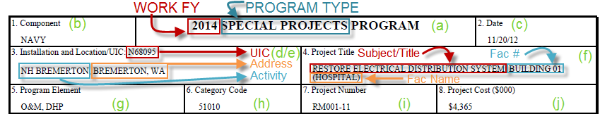
  - Report Title: Composed of the Program Type and Work FY fields. Note: The fiscal year listed here implies the funding year of the Program Element(s) specified in Block 5.
  - Component: Defaults to “NAVY”; can be manually overwritten.
  - Date: Displays the date when the user generated or refreshed the report in Business Objects. Can be manually overwritten.
  - Activity Name and UIC: Displays the UIC and Name of the Activity associated to the Facility. If this section is blank, see the section entitled “Editing the DD-1391” for instructions on entering it manually.
  - Address: Displays country when it is not “US” or “USA”
  - Project Title: Displays the Subject/Title, Facility Number and Facility Name
  - Program Element: Defaults “O&M, DHP”. This can be manually overwritten.
  - Category Code: Comes from the prime use category code of the Facility Record. Because the DoD list of Category Codes changes from time to time, the most up-to-date code for a given Facility may not be available in DMLSS. In that case, this field must be manually overwritten.
  - Project Number: Comes from the Local Project # of the Requirements Package.
  - Project Cost: This amount comes from the Total Funded Cost on the Worksheet of the Requirements Package. Shown in thousands of dollars.
- Block 9 – Cost Estimates: All amounts are in thousands of dollars. 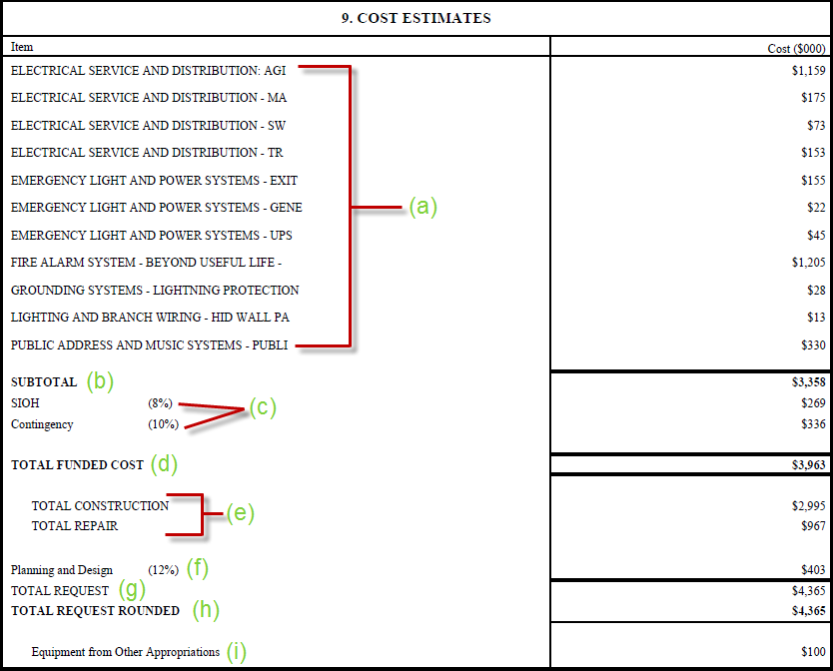
  - Individual Requirements: Displays the title of each Individual Requirement and its corresponding Work ($) amount. Note: These are listed in alphabetical order. For information on sorting them differently, see the section entitled “Formatting the DD-1391”.
  - Subtotal or Adjusted Subtotal: Comes from the total of the Detailed Cost Breakdown at the end of the 1391. As such, this is the total of all line items multiplied by the Adjustment Factor. If the Adjustment Factor is exactly 1.00 then it will be listed as the “SUBTOTAL”, otherwise if the Adjustment Factor is not equal to 1.00 then it will be listed as the “ADJUSTED SUBTOTAL”. This number may vary significantly from the simple addition of the Individual Requirement Estimates, either due to an Adjustment Factor, or a difference of Line Items between the Individual and Requirements Packages. This number matches the total of the Detailed Cost Breakdown. If a separate Cost Estimate is to be attached, the subtotal before Overhead and Planning & Design costs must match this entry.
  - Overhead: Lists the Overhead Type, Percentage and Absolute Value of Overhead entries with a type of “SIOH” and “Contingency”. These are the only types that will appear here. Note: SIOH is always listed before Contingency.
  - Total Funded Cost: The sum of the Subtotal/Adjusted Subtotal and the Overhead amounts specified in items (b) and (c).
  - Cost breakdown by Navy Work Classification: Pro-rates the Total Funded Cost according to the Work Classification (Work Method field) specified on each Individual Requirement. If the Work Method field is blank on some of the Individual Requirements, then they will not be included here and the sum will not match the Total Funded Cost. If this is the case, the DD-1391 will be rejected by BUMED.
  - Planning and Design: Lists the Overhead Type, Percentage and Absolute Value of an Overhead entry with the type “Planning and Design”, if present on the Worksheet.
  - Total Request: The sum of the Total Funded Cost and the Planning and Design cost in items (d) and (f). Includes Planning and Design costs regardless of whether the “Include P/D Overhead in Total Cost” box is checked on the Worksheet of the Requirements Package. Note: This entry is always rounded down.
  - Total Request Rounded: The Total Request amount is rounded up if necessary in this field.
  - Equipment from Other Appropriations and Temporary Facility Costs: These amounts come from the related fields on the Estimate Tab of the Requirements Package and do not factor into any of the totaled amounts. Each line will only show up if the amount is greater than $0.
- Block 10 – Description of Proposed Construction: The description of the Requirements Package. 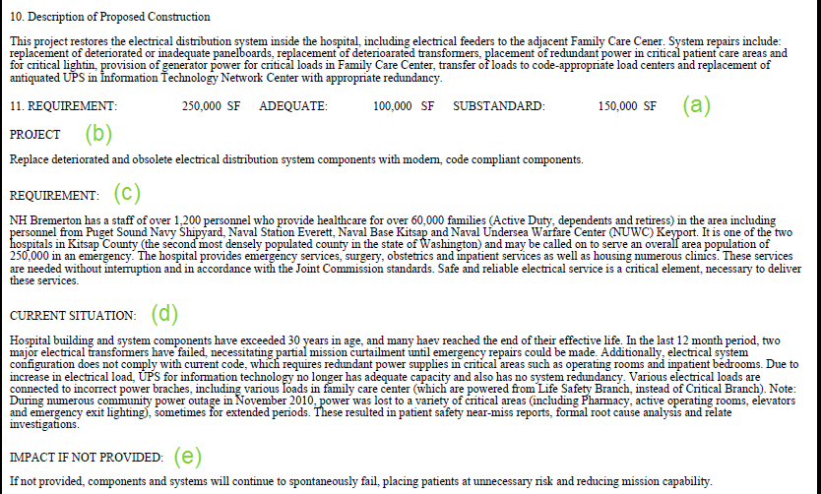
- Block 11: All information comes from the Requirements Package only:
  - Requirement, Adequate and Substandard Area
  - Project Explanation
  - Requirement Explanation
  - Current Situation
  - Impact If Not Provided
- Additional Data: 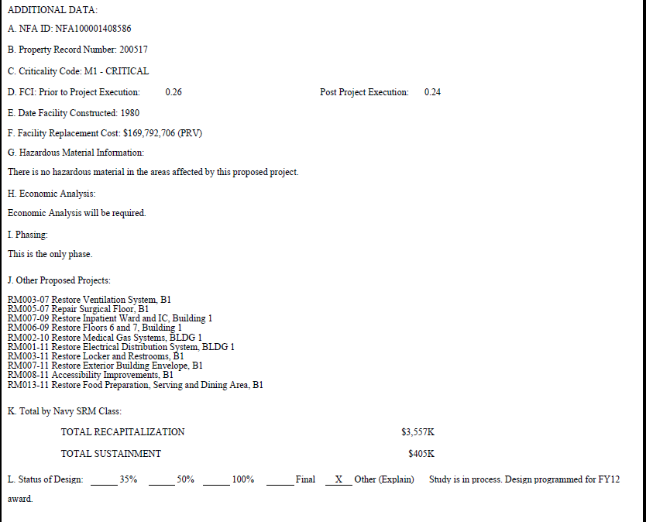
- NFAID: From the Local Use field of the Facility Record
- Property Record Number: From the Facility Record
- Criticality Code – Determined from the Requirement Code and Criticality of the Requirements Package. For example, Mission and 3 - Moderate becomes M3 – Moderate. If a Criticality of “1 – Imminent” is chosen in DMLSS, it will appear as “1 – Critical” on the DD-1391, as in the screenshot.
- FCI – The Pre-FCI and Post-FCI ratios. Please see the section “Facility Condition Index” for more information.
- Date Facility Constructed: Only shows the year.
- Facility Replacement Cost: The Plant Replacement Value of the Facility
- Hazardous Material Information (Requirements Package)
- Economic Analysis (Requirements Package)
- Phasing Summary (Requirements Package)
- Other Proposed Projects (Requirements Package)
- Total by Navy SRM Class: Pro-rates the Total Funded Cost according to the SRM Class (Requirement Type field) specified on each Individual Requirement.
- Status of Design: The appropriate line is automatically filled in with an “X”. If there is a Design Status Explanation it will appear to the right.
- Attachments: A text field showing a list of possible attachments. Please see the section entitled “Editing the DD-1391” for details on filling this section out. 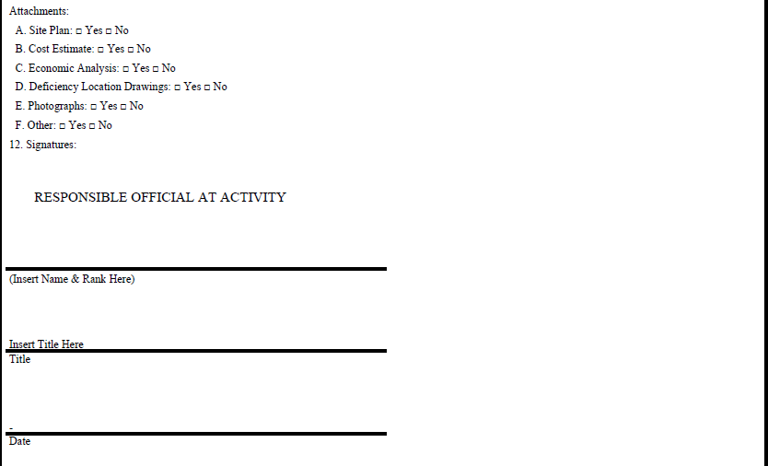
- Block 12 (Signatures): There are three sections (Activity, Region and Headquarters); however, only one is shown here. Please see the section entitled “Editing the DD-1391” for details on filling this section out.

- Detailed Engineering Cost Estimate: This section replicates the worksheet of the Requirements Package verbatim. The line items are totaled at the end; the total is shown in thousands of dollars. If the Adjustment Factor for the Requirements Package is not equal to 1.00 then the Adjustment Factor and the Adjusted Subtotal are shown as well. The Subtotal/Adjusted Subtotal matches the corresponding amount shown in Block 9. Note: This section always starts on a new page so that the user can choose whether to print it. Also, the line items are listed in alphabetical order. For information on sorting them differently, see the section entitled “Formatting the DD-1391”.
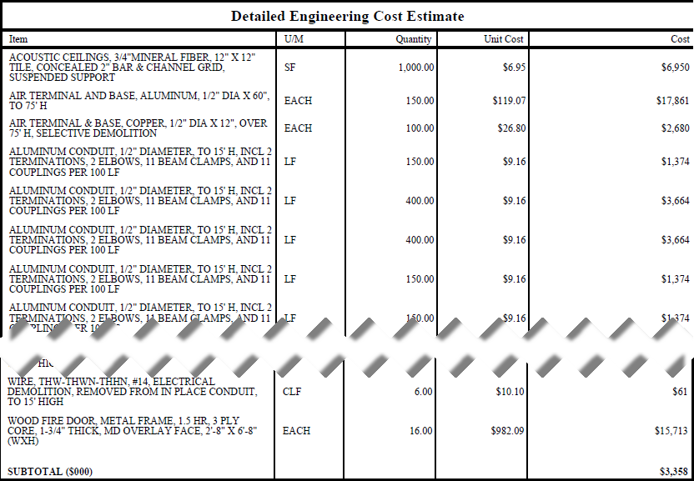
OR
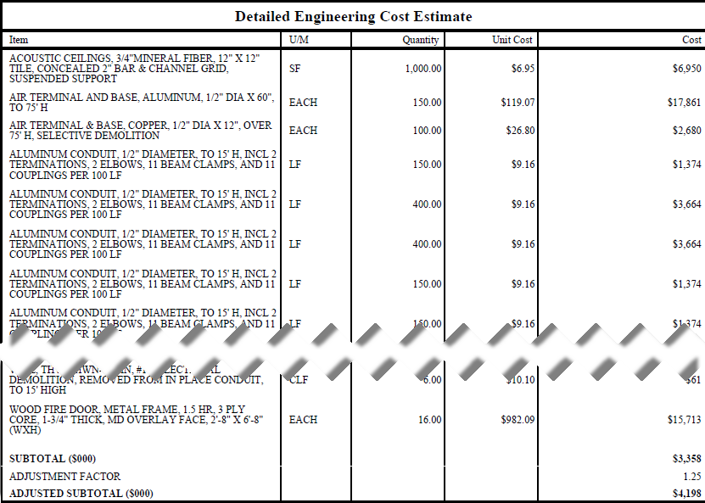

GLOSSARY

PART I. ABBREVIATIONS AND ACRONYMS

ASD(HA) | Assistant Secretary of Defense for Health Affairs
BOD | Beneficial Occupancy Date
CATCODE | Category Code
CQM | Construction Quality Management
DHA | Defense Health Agency
DHP | Defense Health Program
DHAI | DHA Instruction
DHAM | DHA Manual
DM | Deferred Maintenance
DMLSS | Defense Medical Logistics Support System
DoD | Department of Defense
DoDI | DoD Instruction
ESR | Execution Status Report
FAC | Facility Analysis Category
FCI | Facility Condition Index
FDP | Facility Development Plan
FLCM | Facility Life Cycle Management
FSM | Facilities Sustainment Model
FY | Fiscal Year
FYDP | Future Year Defense Plan
HCRA | Health Care Requirements Analysis
HFPO | Health Facilities Planning Office
HQ | Headquarters
MHS | Military Health System
MILCON | Military Construction
MILDEP | Military Department
MTF | Medical Treatment Facility
O&M | Operations and Maintenance
OSD | Office of the Secretary of Defense
PFD | Plan for Design
PPBE | Planning, Programming, Budgeting, and Execution
PM | Project Management
POC | Point of Contact
QA | Quality Assurance
QASP | Quality Assurance Surveillance Plan
QC | Quality Control
RM | Restoration Modernization
RFI | Request for Information
RPCS | Real Property Categorization System
RPI | Real Property Inventory
SF | Square Foot
SIOH | Supervision, Inspection, Overhead
SRM | Sustainment, Restoration, and Modernization
UM | Unit of Measure
WR | Work Request

PART II. DEFINITIONS
Unless otherwise noted, these terms and their definitions are for the purposes of this instruction.

building. A roofed and floored facility enclosed by exterior walls and consisting of one or more levels that is suitable for single or multiple functions and that protects human beings and their properties from direct harsh effects of weather such as rain, wind, sun, etc.

CATCODE. The most detailed level of classification for real property. Denotes a specific real property type and function in accordance with the current version of the RPCS and each MILDEP’s specific documentation.

civil works. Tasks undertaken by the Directorate of Civil Works, U.S. Army Corps of Engineers that include water resource development activities including flood risk management, navigation, recreation, infrastructure and environmental stewardship and also includes emergency response.

Deferred Maintenance (DM). DM is the value of maintenance that was not performed when it should have been or was scheduled to be and which, therefore, is put off or delayed for a future period, reference (p).
disposal. Any authorized method (e.g., demolition, transfer) of permanently divesting the DoD of accountability for, and control of, a real property asset of the United States.

FAC. A grouping of real property assets that have a common UM and equivalent cost based on the UM. Included in this equivalent cost are costs associated with real property construction, maintenance, sustainment, and repair. Within the DoD, a FAC is represented by a four-digit numerical code, as found in DoDI 4165.03 (Reference (s)) and the current version of the RPCS.

facility. A building, structure, or linear structure whose footprint extends to an imaginary line surrounding a facility at a distance of 5 feet from the foundation that, barring specific direction to the contrary such as a utility privatization agreement, denotes what is included in the basic record for the facility (e.g., landscaping, sidewalks, utility connections). This imaginary line is commonly referred to as the “5-foot line.” A facility will have an RPUID received from the RPUIR and is entered into a Service RPI system as a unique real property record.

forecast. A prediction of future real property assets, including acquisitions, transfers, and disposals, to support the DoD mission.

FSM. A model used to determine funding levels for sustainment and restoration and modernization. Projects annual facility sustainment costs for the DoD facilities inventory.

FYDP. Program and financial plan for the DoD, as approved by the Secretary of Defense. The FYDP arrays cost data, manpower, and force structure over a 6-year period (force structure for an additional 3 years), portraying this data by major force program for DoD internal review for the program and budget review submission. It is also provided to the Congress in conjunction with the President’s budget.

historic status. The status of a facility with respect to the National Register of Historic Places.
IBE. Synonymous with RPIE.

installation. A base, camp, post, station, yard, center, homeport facility for any ship, or other activity under the jurisdiction of the Department of Defense, including any leased facility, which is located within any of the States, the District of Columbia, the Commonwealth of Puerto Rico, American Samoa, the Virgin Islands, the Commonwealth of the Northern Mariana Islands, or Guam. Such term does not include any facility used primarily for civil works, rivers and harbors projects, or flood control projects. In the case of an activity in a foreign country, an installation is any property under the operational control of the Secretary of a MILDEP or the Secretary of Defense, without regard to the duration of operational control. For real property accountability, an installation must consist of one or more real property sites.

interest. The type and extent of ownership of property or for the use of property, including an easement to pass over an adjacent parcel, mineral rights, outright title, or a possibility of acquiring title should a specified event occur. DoD real property interest types are defined in the RPIM.

internal control. An integral component of an organization’s management that provides reasonable assurance that the following objectives are being achieved:
• Effectiveness and efficiency of operations.
• Reliability of financial reporting.
• Compliance with applicable laws and regulations.

Synonymous with management control, helps government program managers achieve desired results through effective stewardship of public resources.
International Organization for Standardization. Defined in Joint Publication 4-09 (Reference (u)).

land. A portion of the Earth’s surface distinguishable by boundaries. Land must be accountable by parcel starting when the parcel was transferred into a MILDEPs’ or the WHS’ custody and control.

land parcel. A real property asset identified as a specific area of land having a unique acquisition document and a legal description of its boundaries and whose perimeter is delineated by a cadastral survey, as recorded in the land records of the government entity having appropriate jurisdiction.

linear structure. A facility whose function requires that it traverse land (e.g., runway, road, rail line, pipeline, fence, pavement, electrical distribution line) or is otherwise managed or reported by a linear UM at the CATCODE level.

predominant current use. The primary use of a real property asset based on the largest quantity of usage for an activity or function as described by the appropriate FAC or CATCODE.

real property. Land and improvements to land (e.g., buildings, structures, and linear structures (see facility)).

Repair. The term “repair project” means a project to restore a real property facility, system, or component to such a condition that it may effectively be used for its designated functional purpose. It includes repair or replacement work to restore facilities damaged by inadequate sustainment, excessive age, natural disaster, fire accident, or other causes, reference (p).

RPAO. An individual (government employee) who, based on his or her training, knowledge, and experience in real property management, accountability, and control procedures, is appointed by proper authority to be responsible for the establishment of records and maintenance of physical accountability for the real property charged to the accountable area or installation.

RPCS. A hierarchical scheme of real property types and functions that serves as the framework for identifying, categorizing, and analyzing the DoD’s inventory of land and facilities around the world (see Reference (t) for more information). An updated table of FAC and CATCODES is published at least annually.

RPI. A detailed record (listing, system) of real property lands, buildings, structures, and linear structures.

RPIE. An item of equipment that is affixed and built into a facility as an integral part of that facility. To qualify as RPIE, the equipment must be necessary to make the facility complete, and if removed, would destroy or severely reduce the designed usefulness and operation of the facility. RPIE costs are included as a funded initial construction or renovation cost. RPIE may be accounted for as a real property equipment asset record, but not as a separate facility record in the real property inventory. RPIE includes such items as control systems, heating, cooling, electrical, emergency lighting, etc.

RPUID. A non-intelligent code used to permanently and uniquely identify a DoD real property asset.

RPSUID. A non-intelligent code used to permanently and uniquely identify a DoD real property site.

site. Physical (geographic) location that is, or was owned by, leased to, or otherwise possessed by a DoD Component on behalf of the United States. Each site (except for leased) is assigned to a single installation. A site may exist in one of three forms:

Land only, where there are no facilities present and where the land consists of either a single land parcel or two or more contiguous land parcels.
Facility or facilities only, where the underlying land is neither owned nor controlled by the government. A stand-alone facility can be a site. If a facility is not a stand-alone facility, it must be assigned to a site.

Land, and all the facilities thereon, where the land consists of either a single land parcel or two or more contiguous land parcels.
structure. A facility, other than a building or linear structure, that is constructed on or in the land.

Available at: www.wbdg.org or http://www.acq.osd.mil/ie/fim/programanalysis_budget/tool_metrics/FPG/fpg.shtml

