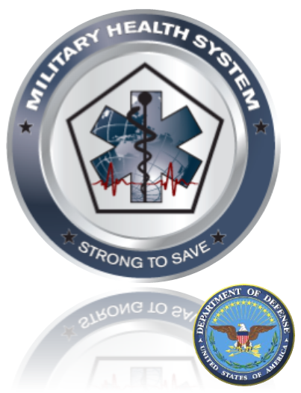
Contract: In House | Task Order: In House

DHA Facilities
  - In Processing Checklist and Welcome Packet
Welcome to the DHA Facilities Division. We are glad you are part of the team!
DRAFT
www.facilities.health.mil
Prepared for MHS Facilities by:
DHA Facilities Operations Support Team
Tel 703.681.4324  Fax NA | 7700 Arlington Blvd.  Falls Church, VA 22042 | www.facilities.health.mil  venus.thompson.ctr@tma.osd.mil

Contents
Director’s Welcome 1
Checklist 2
Points of Contact Details 6
Company Information 6
Resources 7
List of Forms 8

File Name: DHA Facilities Division - In Processing Checklist - 130920.docx
Project Tool Link: https://facilities.health.mil/repository/getFile/12369
Key Words: MHS;DoD;DHA Facilities; In Processing; Checklist

Director’s Welcome
“Got something very important to point out to your readers about the summary?”

Quadruple Aim
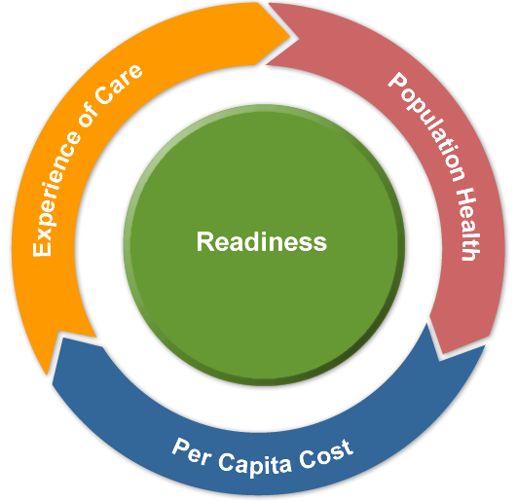
Population Health: Improving quality and health outcomes for a defined population. Advocating and incentivizing healthy behaviors.
Per Capita Cost: Managing the cost of providing care for the population. Eliminate waste and reduce unwarranted variation; reward outcomes, not outputs.
Experience of Care: Patient and family centered care that is seamless and integrated. Providing patients the care they need; exactly when and where they need it.
Readiness: Enabling a medically ready force, a ready medical force, and resiliency of all MHS personnel.

Welcome to the team!
I would like to welcome you to the Defense Health Agency (DHA) Facilities Division Team!

Our mission is to support the military health system (DHA) through effective world class health facilities life cycle integration and management. As one of the DHA shared services we have the privilege of coordinating and guiding the integration of planning, programming, design, construction, activation and operations for direct care medical, dental, veterinary and medically related research facilities around the world. This supports our active service members and their families to ensure a medically ready and ready medical force for the United States Department of Defense.

We are excited you have chosen to join our team. This packet provides the necessary in processing steps required to enable you to be an effective member of our team and work within the DHA organization.
John Becker
Director, Defense Health Facilities (DHA) Facilities Division
September 27, 2013

Checklist

Facilities
If you have questions please contact DHA Facilities Operations Support Team at 703.681.4324.
The following items are required to complete your part of the in processing to DHA. When you complete the below items please return this completed form to DHA Facilities Operations Support Team.

Check List
Item/Description | Contact Group | AD | GS | Contract | SupervisorOnly | Date | Initial
Send Word Now emergency notification system | ADM | X | X | X
Receive valid DoD CAC | CAC | X | X | X
DHA FD Personnel Database | FD | X | X | X
Max.gov ATO C&A (OMB) calendar sharing | GEN | X | X | X
OF-306 Declaration for Federal Employment | HR |  | X
I-9, Employment Eligibility Verification | HR |  | X
SF-61, Appointment Affidavit | HR |  | X
SF-144, Statement of Prior Federal Service | HR |  | X
SF-181, Ethnicity & Race Identification | HR |  | X
SF-256, Self-Identification of Handicap | HR |  | X
SF-1199A, Direct Deposit Sign-Up Form | HR |  | X
W-4, Federal Tax Withholding Allowance Certificate | HR |  | X
State Withholding Allowance Certificate | HR |  | X
Address Form | HR |  | X
Emergency Notification Form | HR |  | X
Reserve Status | HR |  | X
TSP Loan Information | HR |  | X
Conditions of Temporary Employment (Temp Hires Only) | HR |  | X
Conditions of Intermittent Employment (Intermittent Hires Only) | HR |  | X
SF-15, Claim for 10 point Veteran’s Preference (Only for those claiming 10 point Vet’s Preference) | HR |  | X
Letter from Veteran’s Administration dated within last 12 months (Only for those claiming 10 point veteran’s preference) | HR |  | X
SF-813 Verification of Credible Campaign Service (Retired Military Only) | HR |  | X
DD Form-214, Certificate of | HR |  | X
Release from Active Duty (If served in the military, bring copy of your DD-214 showing all military service) | HR | X
DHA Uniformed Services Military Contact Information | HR | X
Statement of Annuity Earnings for Civil Service Annuitants (Retired Annuitants, bring statement of annuity earnings | HR |  | X
Supervisors: Access to FASCLASS (Position Descriptions) | HR | X | X
DAI Time and Attendance Training | HR |  | X
Establish DHA Account  DHA Form 8, Contractor Add User Form  DHA Form 9, Government Add User Form | IT | X | X | X
Car/Van Pool permits, Shuttle passes | PO | X | X | X
No Fear Act Training (every 2 years) | T | X | X
Constitution Day Awareness Training (new employees) | T | X | X
Combat Trafficking in Persons (CTIP) Training | T | X | X
HIPAA/Privacy Training | T | X | X | X
Counterintelligence and Reporting Training | T | X | X
Information Assurance Training | T | X | X | X
Anti-Terrorism Training | T | X | X | X
Ethics Training | T | X | X | X
Information Security Awareness Training | T | X | X | X
Performance Management Training | T | X | X
Supervisory Training | T | X | X |  | Yes
Reasonable Accommodations Training | T | X | X |  | Yes
Don’t Ask Don’t Tell (ALL Uniformed Service members; senior civilian leadership and civilian employees who directly supervise service members) | T | X | X
SACCP Action Officer Training (for Applicable Employees) | T | X | X | X
Register for ELD Training (Provide copy of required training) | T | X | X | X
Telework Training | T |  | X

Contact Information
Office | Abbr. | Contact Info
Administration | ADM | Send Word Now  Brenda Lugo Brenda.Lugo.CTR@dha.mil  703-681-9073  Telework Training  Crystal Thompson - Crystal.Thompson.CTR@dha.mil  703-681-7194  Personal Security Branch (PSB)  CIV/MIL – Yvette Scott - Yvette.Scott@dha.mil  703-681-1158  Contractor – Preston Ford - Preston.Ford@dha.mil  703-681-8707
Common Access Card | CAC | Appointments https://facilities.health.mil/repository/getFile/12515  (703) 681-5744  Contractor CAC Process  https://facilities.health.mil/repository/getFile/10066  Find a RAPIDS site https://facilities.health.mil/repository/getFile/12516
Facilities | FAC | Office/Equipment Moves  Pernell Hunter - Pernell.Hunter@dha.mil  703-681-6788  DHHQ Facilities  TMAFacilities@tma.osd.mil
DHA Facilities FD | FD
General | GEN | Max.gov ATO C&A (OMB)  DHA FD Main Desk 703-275-6077
Human Resources | HR | GS  Ben Hays - Ben.Hays@dha.mil  (703) 681-8703  FAQ & Answers for Civilians Transferring to DHA  https://facilities.health.mil/repository/getFile/12901  Active Duty | Uniformed Services  Derek Ladson – Derek.Ladson@dha.mil  (703) 681-9525  Contractors  Contact your FSO  FASCLASS for Position Descriptions (Supervisors Only)  Joe Piemontese – Joe.Piemontese@dha.mil  (703) 681-7841  DAI Time and Attendance Training  Barbara Berry – Barbara.Berry@dha.mil  (703) 681-8983
Information Technology | IT | Computer & Technology Issuance  Robert Moss - Robert.Moss@dha.mil  (703) 681-3492 (Replacing Burton Ziskind)  Joseph Winbush - Joseph.Winbush@dha.mil  (703) 681-7995
Parking Office | PO | Visitor & Parking Requests & Car/Vanpool Permits  Parking&VisitorRequest@dha.mil  (703) 681-9532
Training | T | Enterprise and Learning Development Division(ELD) Training Database  (703) 681-5360  Register for training classes  https://webapps.tma.osd.mil/trainingdatabase  Report issues or need a new account  MTDBInquiries@tma.osd.mil  List of available training courses https://facilities.health.mil/repository/getFile/12608

Points of Contact Details
You can find more information at the DHA Facilities page:
https://facilities.health.mil/home/DHAFacilities

Company Information
DHA Facilities Operations Support Team
7700 Arlington Blvd.
Falls Church, VA 22042
Tel 703.681.4324
Fax NA
www.facilities.health.mil



Resources

Acronyms
You may also use this link to help you find other acronyms not on this list: http://www.acronymfinder.com/

Online Resources:
Resources are also available on the MHS’s Facilities Website. Information on various subject specific areas is highlighted on multiple topic knowledge pages and other tools in the World Class Facilities (WCF Toolkit):
www.facilities.health.mil
Tools include:
- Knowledge Center (documents used with in the MHS Facilities community)
- Knowledge Pages (topic focused knowledge pages such as SEPS, DMLSS, BIM, etc.)
- Project Tool (project specific document and information portal)
- World Class Facilities Checklist
- Capital Investment Decision Model (CIDM) Tool (facilities capital investment decision support tool)

List of Forms
The following is a list of reference forms:
Form | Link
DHHQ Office/Equipment Move Form | https://facilities.health.mil/repository/getFile/12469
Link to various Office of Personnel Management (OPM) Standard Forms | https://facilities.health.mil/repository/getFile/12610
Link to various Department of Defense (DoD) Forms | https://facilities.health.mil/repository/getFile/12703
DHA Uniformed Services Personnel MIL Contact Information Form | http://facilities.health.mil/repository/getFile/12612
Government Add User Form - DHA Form 9 | https://facilities.health.mil/repository/getFile/12372
Contractor Add User Form - DHA Form 8 | https://facilities.health.mil/repository/getFile/12590
FASCLASS Position Description Libraries Form | https://facilities.health.mil/repository/getFile/12674
Send Word Now Sign Up Form | https://facilities.health.mil/repository/getFile/12693
Max.gov Calendar Sharing | https://facilities.health.mil/repository/getFile/10560
DHHQ Visitor and Parking Request Form | https://facilities.health.mil/repository/getFile/8191
DHHQ Large Groups Visitor and Parking Request Form | https://facilities.health.mil/repository/getFile/12180
TMA Civilian Fitness and Wellness Program Memorandum  TMA Civilian Fitness and Wellness Agreement | https://facilities.health.mil/repository/getFile/12898  https://facilities.health.mil/repository/getFile/12899
Alternative Work Schedule – TMA Form 1 | https://facilities.health.mil/repository/getFile/12900

